**IS 722 – Fall 2022**

**Demo D3**

**Submitted by :**

**Neha Reddy**

**Nitisha Nahar**

**Tejaswini Ginjipalli**

**Yogichandar Boppana**

1)Search for all books that have been authored by a specific author of your choice

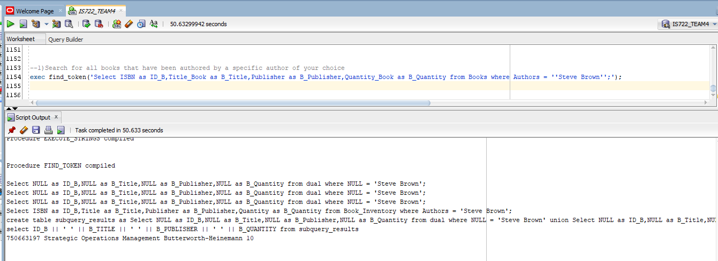

2)Search for all CDs that feature a specific artist

3)Display a few columns of your choice from existing orders in the local databases

4)Search for each product with at least quantity N (you choose what N is)

5)Display all orders of a particular customer

6)Create your own scenarios, showcasing how great your system is

7)How the algorithm was able to perform when there are missing attributes in the other DB's(Credit card was just present in db3)

8) How the algorithm was able to convert or was able to handle the data of different types.

-Phone number was a number in local database 4 where as it was string in other data bases.

-Concatenated the address in DB4, as state, city and country were in different columns.

